TranslateMe App – Walkthrough

**⚠️ Note: Unfortunately, this is the only form of demonstration I can provide. I’ve been working exclusively on FIU library computers, which in most of cases and programs failed to run iOS simulators due to extremely outdated and underpowered hardware. Additionally, these machines do not allow the installation of third-party recording software such as OBS or screen capture tools. Because of these constraints, I was unable to create a proper walkthrough video.**

**However, I have included screenshots along with detailed explanations of every part of the code I wrote myself, so reviewers can clearly understand the core functionality and logic behind the app.**

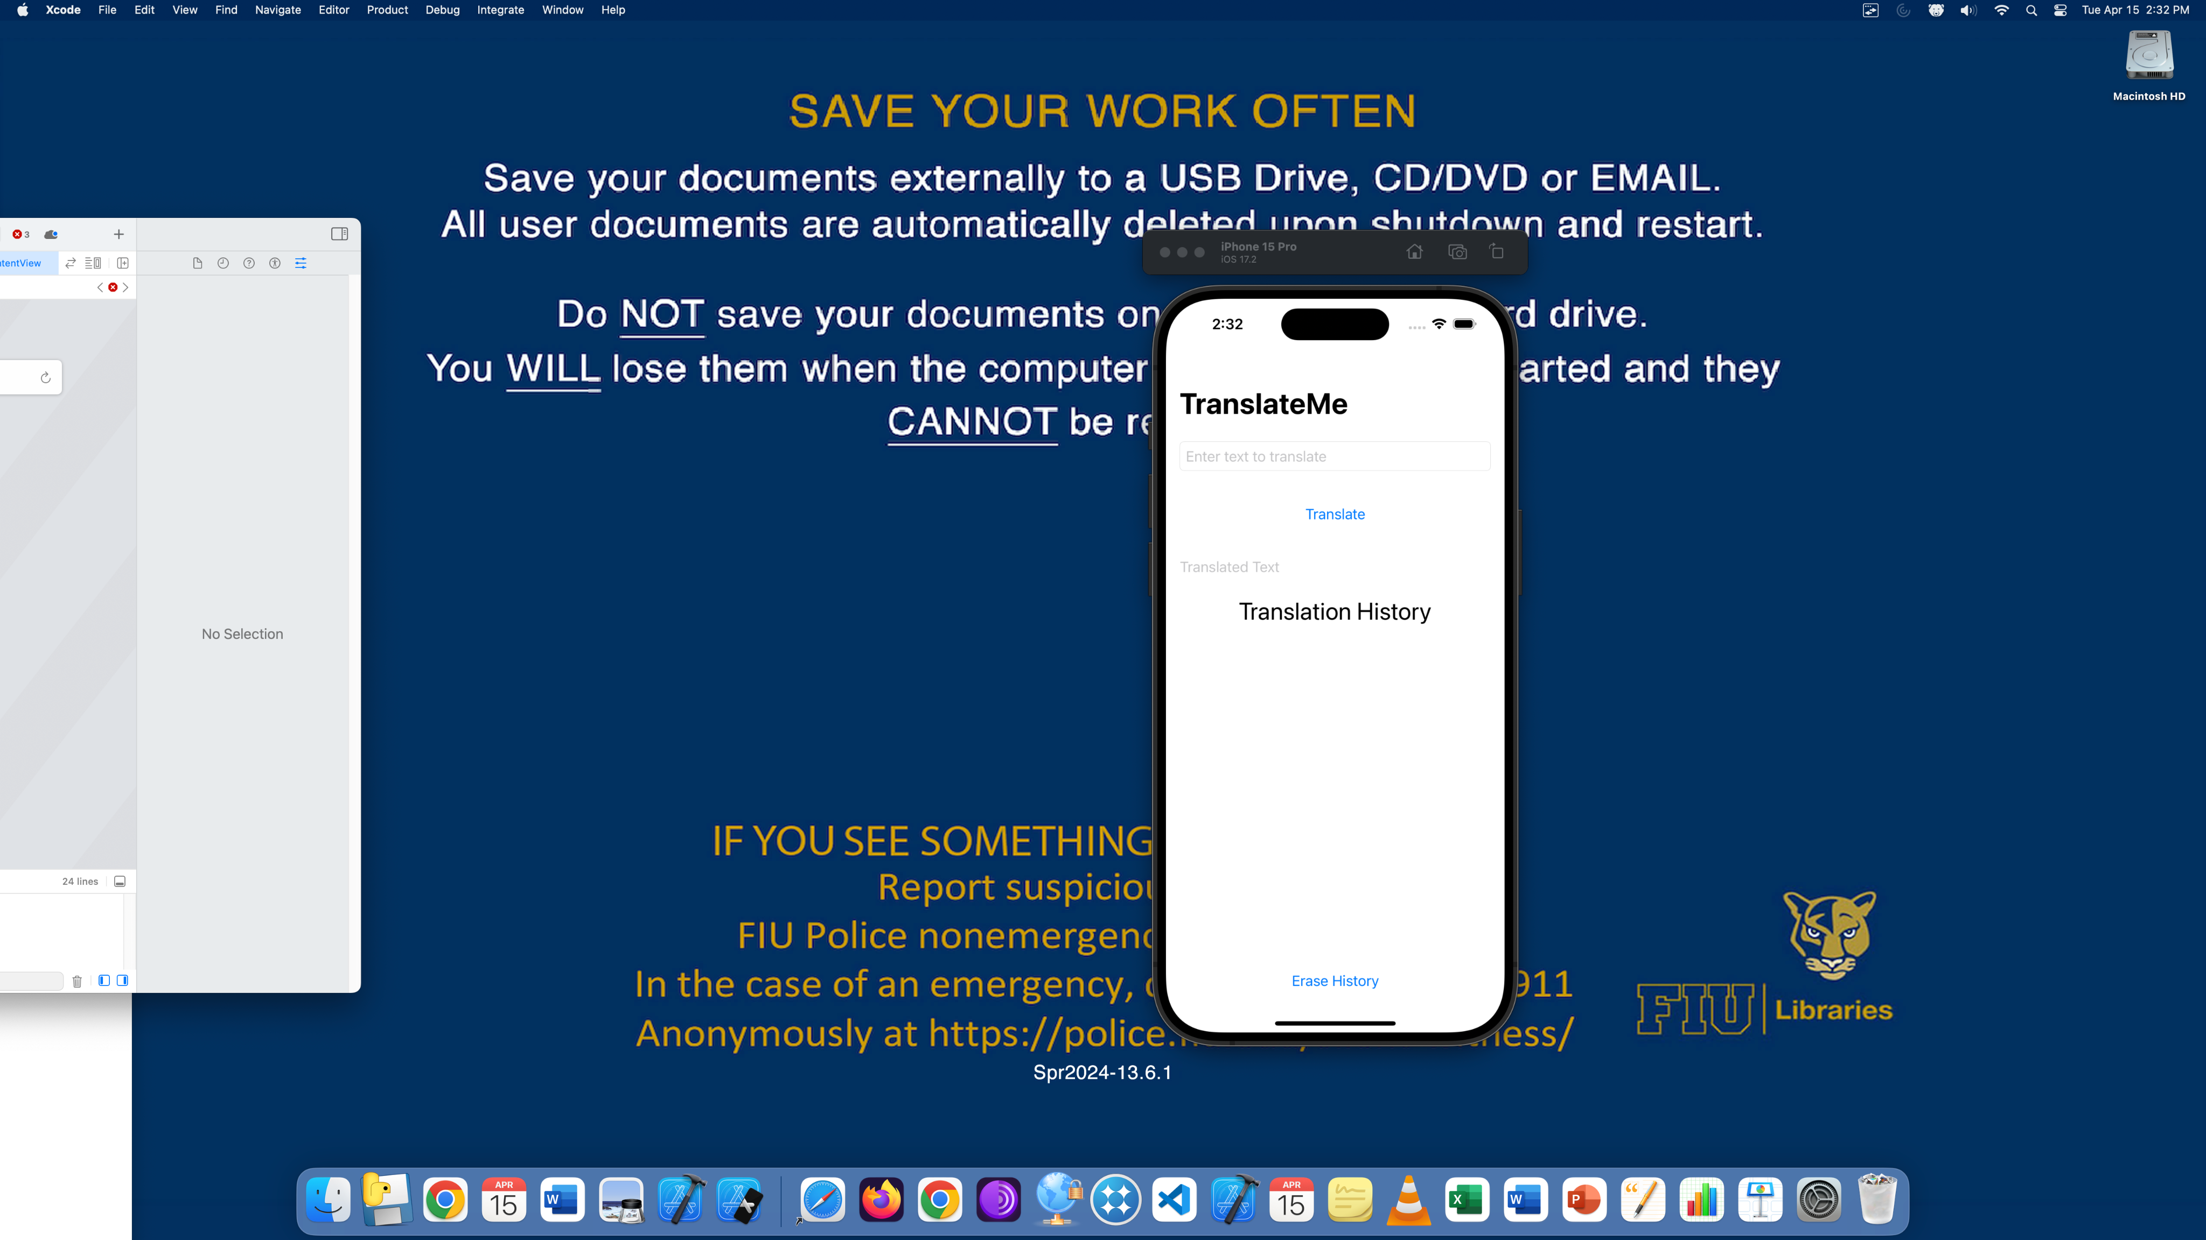

App launch screen with input field, translate button, and empty output/history section.

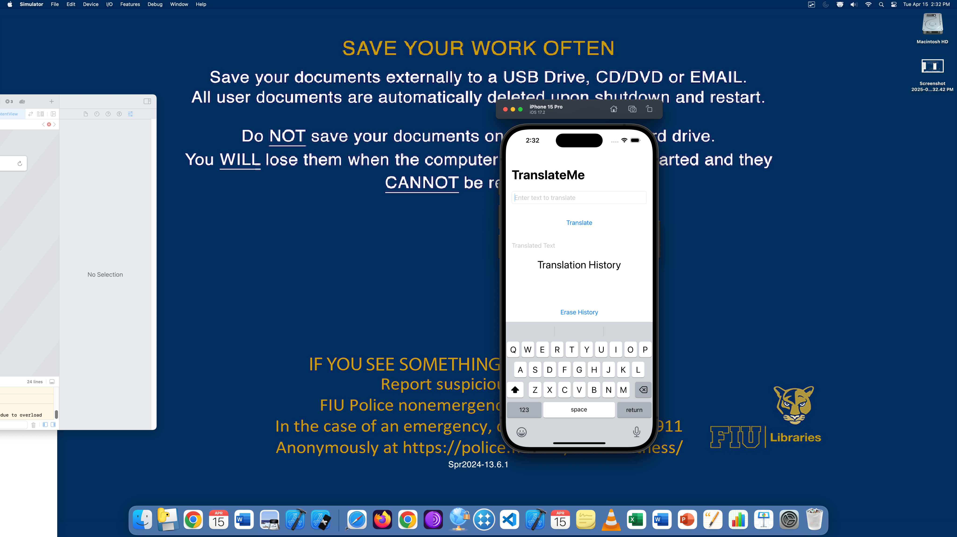

User begins typing 'Hello World' into the input field.

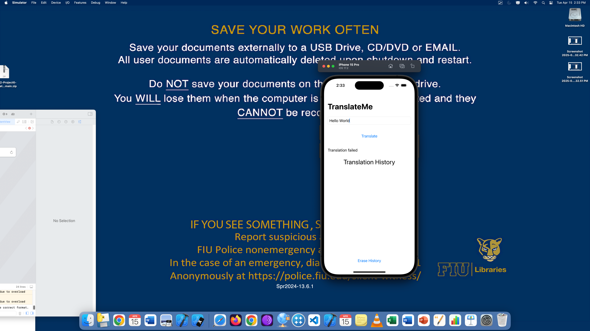

'Translate' button pressed, but translation failed. Message shown below and history starts to populate.

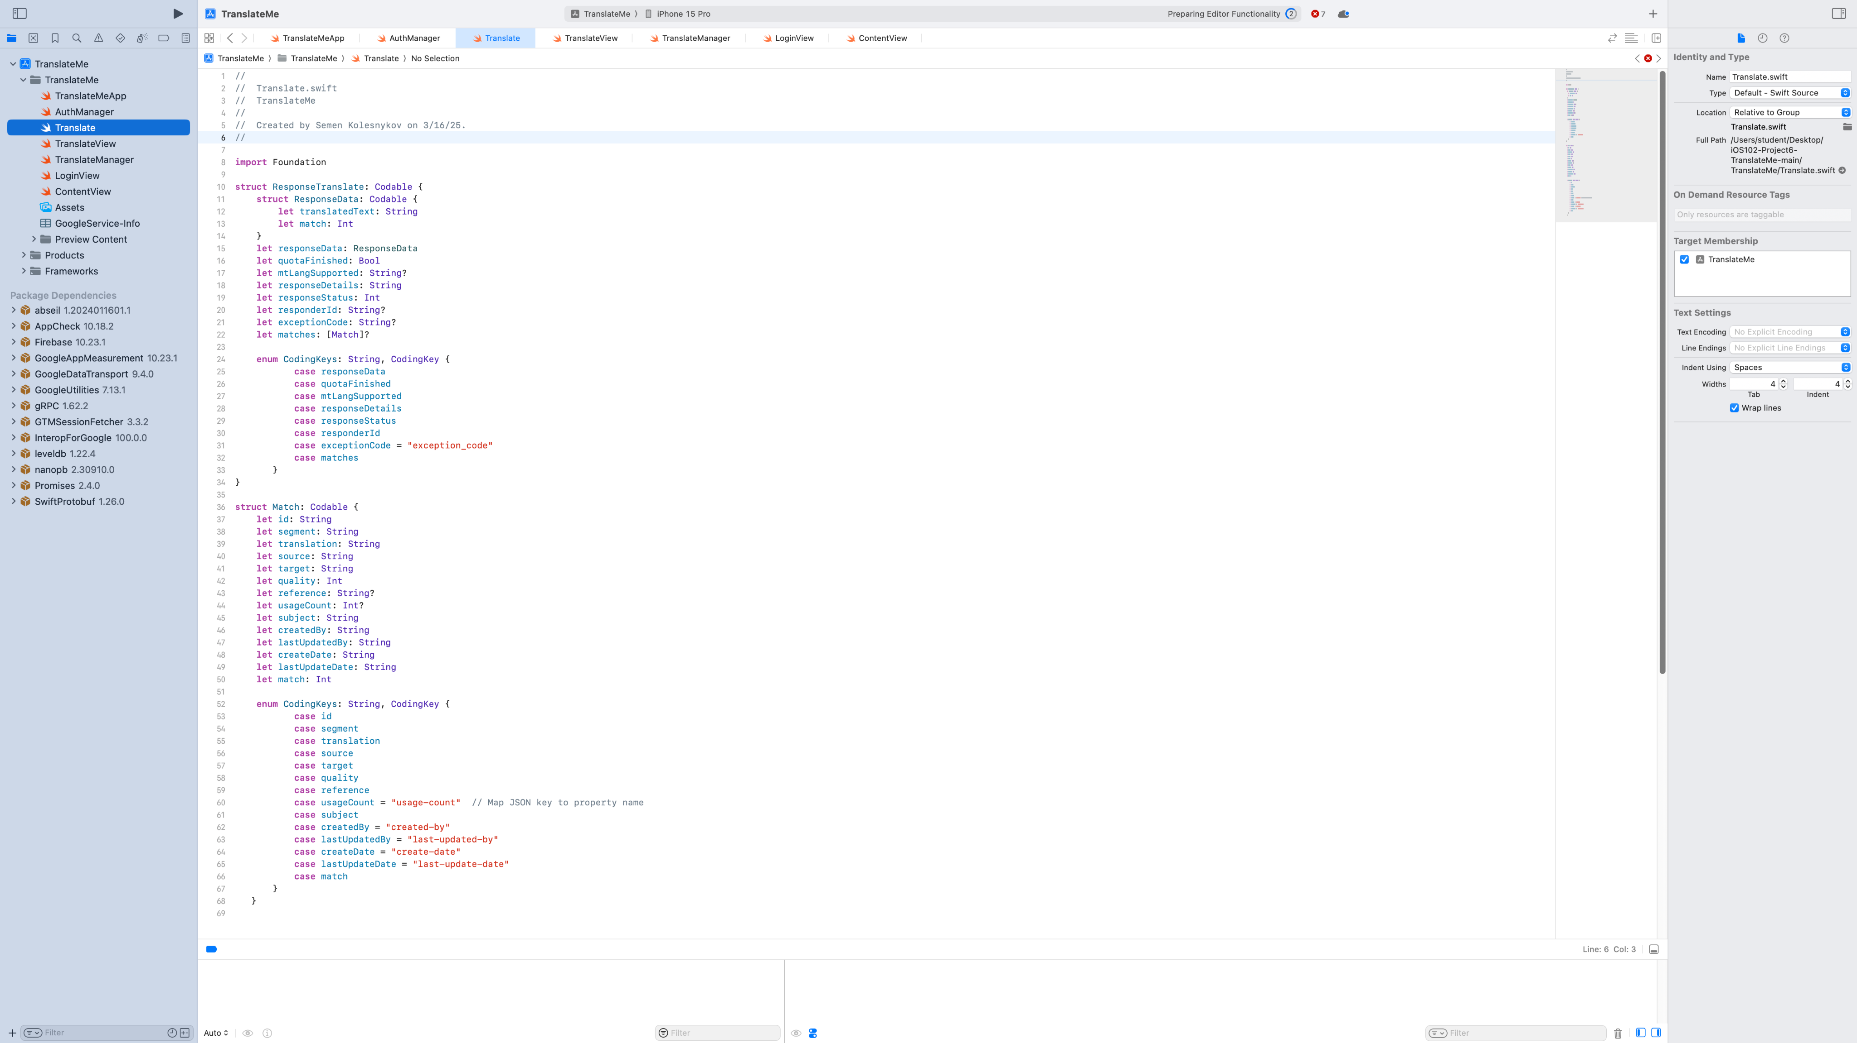

Translate.swift file: response model for parsing API response.

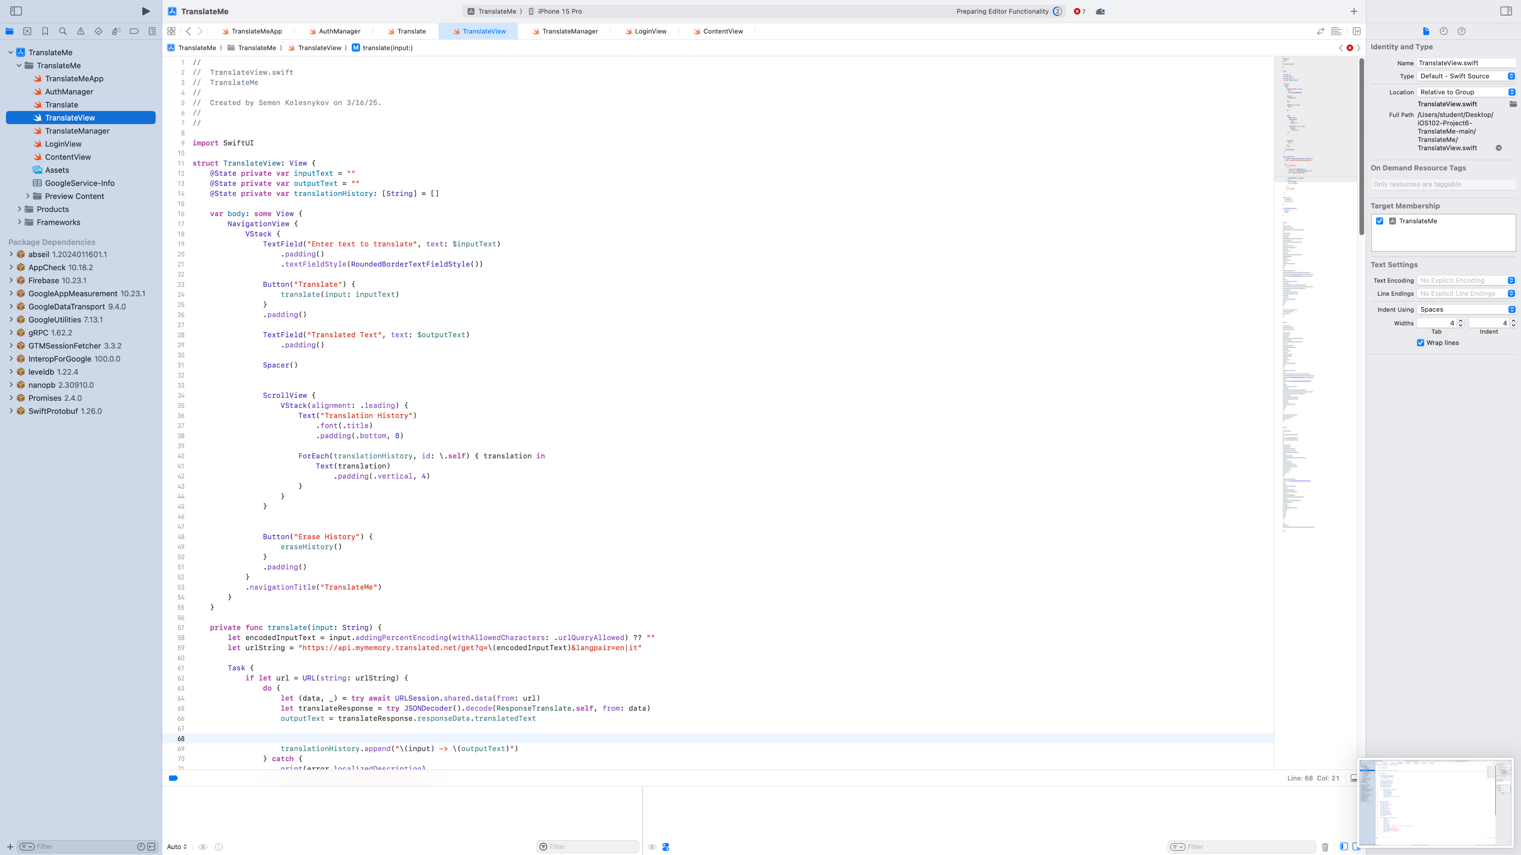

TranslateView.swift: translation logic and view layout.

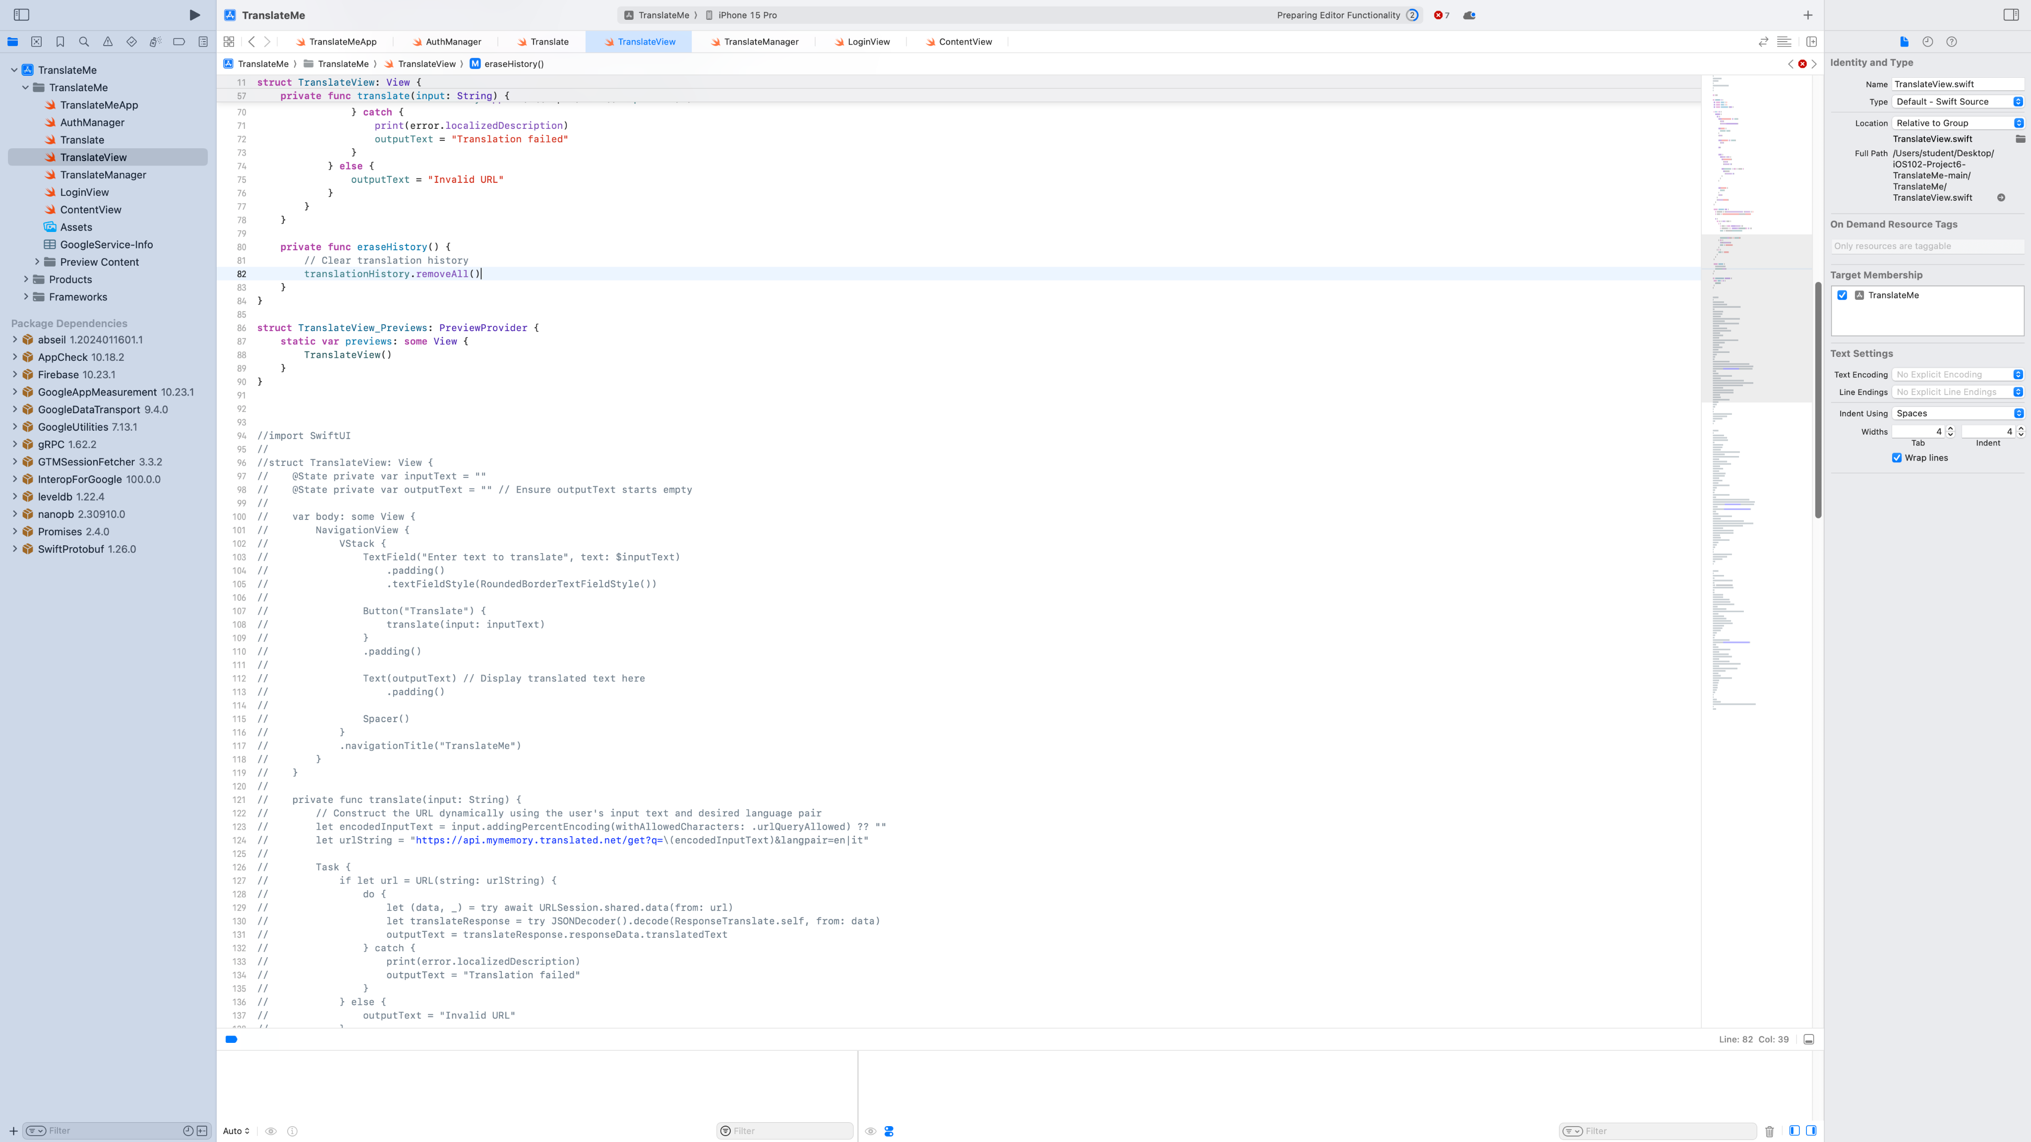

ScrollView with translation history display.

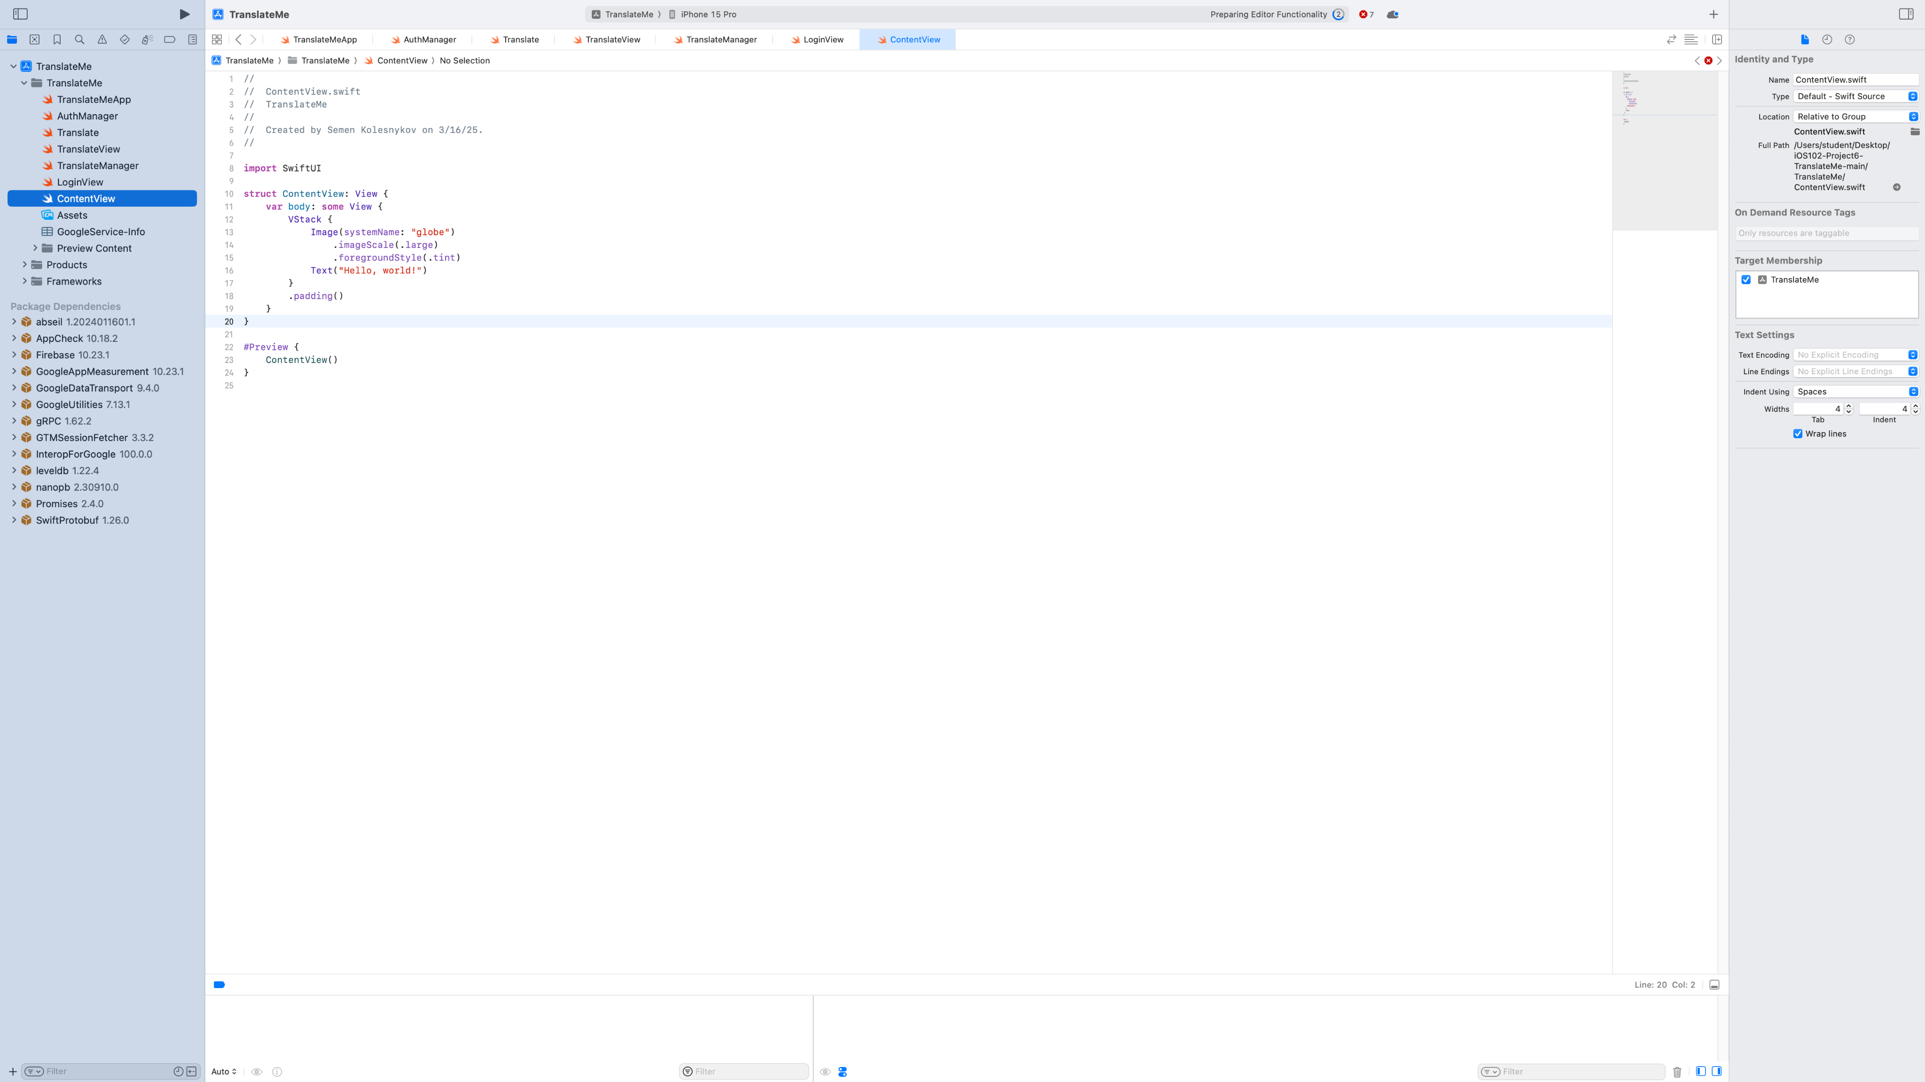

TranslateView continues: eraseHistory function to clear stored translations.